CHW3M Exam Review
This learning guide work gives students the opportunity to review the following expectations from the Canadian and World Studies curriculum:
Exam Format
Part | Category | Question Format | Value | Part Value
Part A | Knowledge/historical | Multiple Choice | 25 – 30 x 1 mark each | 25 – 30 marks
Part B | Knowledge/historical | Map location list | 10 x 1 mark | 10 marks
Part C | Thinking/Big Ideas – making connections | Paragraph Response 2/4 | 2 x 5 marks | 10 marks
Part D | Thinking/Application - Legacy | Essay (1/2) | 1 X 20 marks | 20 marks

Total: 60 - 70 marks
Section 1 – World History Vocabulary – correlates to parts A, C and D of exam
In every CHW3M learning guide, you have been presented with key terms and concepts. Although you were not required to compile a vocabulary list for this course, you were expected to a) gain knowledge of these key terms and concepts and b) be able to explain their significance. In addition, you were expected, whenever possible, to incorporate these terms and concepts into your learning guide work (answers to questions) and your culminating tasks. Below is a list of all of these key terms and concepts from the course, organized by learning guide.
To prepare for your final exam, go through these terms and concepts. For those that you are unsure, look them up in your textbook using the page numbers provided. Compile a set of study notes listing and defining the terms you feel are a) most important to world history and b) most challenging to your personal learning.

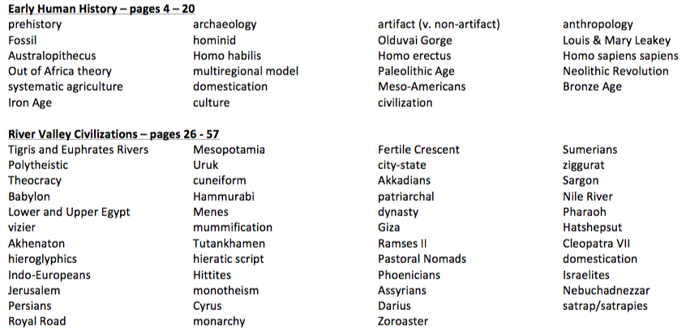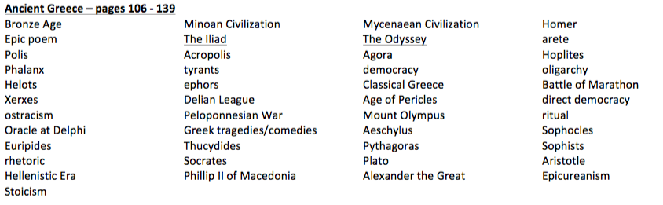
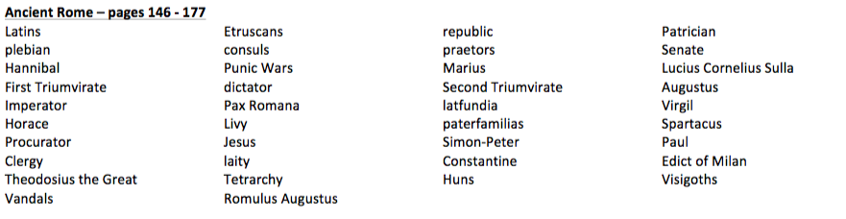
Section 2 – Location, Location, Location – correlates to parts B and C of exam
As you have learned throughout this course, there is an intrinsic relationship between geography and history; geography has consistently shaped the course of events in world history as geographical elements such as landforms, water sources, weather systems and availability of natural resources have all helped or hindered human activities and development. Due to this close link between geography and historical development, several questions in each CHW3M learning guide required you to map geographic locations.
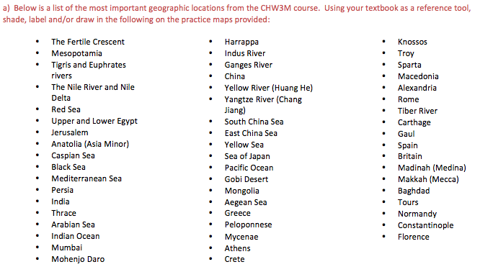
Section 3 – Making Connections/Big Ideas – correlates to parts C and D of exam
As you learned throughout this course, the study of world history is not simply memorizing dates and names; it is about how people lived, interacted, shared ideas and progressed as a human society. Even further, the study of world history is about making connections; understanding how human actions and reactions affect one another. Historical connections may occur both within and between world civilizations/eras.
Historical Connections within World Civilizations/Eras
In CHW3M, you have been categorizing historical events into PESTA (political, economic, social, technological, aesthetic) categories to help you better understand and analyze these interrelationships.
To prepare for your exam, review all “The Development of Religion/Political Systems/Economy/Society – understanding connections within elements of civilizations” questions (and your answers) in your learning guides.
Historical Connections between World Civilizations/Eras
In CHW3M, you have also been learning to think critically about historical events by cataloguing them within fundamental big ideas. In LG #1, Section 3 you were required to review the course’s big ideas (as outlined on pages xxii-xxiii of your textbook) and recreate this list in your CHW3M notebook, leaving space between big ideas.
To prepare for your exam, retrieve and review your big idea list from LG#1 Section 3. Think critically: How can each big idea be applied to several historical civilizations/eras? Select three (3) big ideas that you feel can be easily applied to several world history civilizations/eras. Using specific history examples, explain how each of your big ideas can be applied to a variety of world civilizations/eras. You may choose to simply record your specific examples in the space you left beneath your big ideas, on a separate piece of paper or on a chart – any method is acceptable. Using a graphic organizer such as the cross-classification chart below may be an effective tool for making connections between
Big Idea: Struggle For Rights
Application to World History:

 | Political | Economic | Social | Technological | Aesthetic
Egypt |  |  | Egyptian women sought rights  re: property ownership
Greece
Rome | Roman citizens (plebians)  wanted political representation in their Senate |  | Early Christians (under Roman  rule) sought freedom from religious persecution

Section 4 – Legacy – correlates to parts C and D of exam
Throughout the CHW3M course, you have been asked to identify and critically analyze civilizations’ legacies. Not only have you been asked to identify innovations, aesthetic accomplishments, ideologies, and political, economic and social systems that world civilizations left for other historical peoples to continue to develop, but also analyze how these legacies still have relevance today.
To prepare for your exam, recreate and fill in the “World Civilizations Legacy Chart” below in your notes. One era has been completed for you for exemplar purposes * You will not need to know anything from this Era*

Civilization/Era | Greatest Legacy | Explanation of Legacy | Legacy Significance to Civilization/Era | Legacy Significance to Modern Day
Mesopotamia

Egypt

Ancient Greece

Rome

Renaissance  EXAMPLE | Invention of the printing press by Johannes Gutenberg c. 1440s- 1450s in Germany | Technological - Gutenberg devised a printing device that had moveable type. This meant that individual letter stamps were inserted into the printing device to create text as needed. They could be removed and then reworked to generate different pages of text. | books, which were scarce prior to the 1450s (since they had to be hand-copied) were now easily reproducible. Textbooks now available = development of better education systems/people became more literate  -as people became more educated = more writers emerged generating texts for entertainment (poets, playwrights)  -reproductions of old Classic texts and new Renaissance ones circulated in Europe = Renaissance ideas spread rapidly, new political ideas formed -Martin Luther’s Bible and ideas re: Catholic Church reform circulated = Protestant Reformation occurred in Europe -As the press popularized, people recreated Gutenberg’s invention = gave rise to increased/new industry | The printing press undoubtedly changed Renaissance Europe politically, economically, socially, technologically and aesthetically. However, its impact is still evidenced today in the presence of:  -education systems/universities -vast expanse of literature -Christian denominations/churches that resulted from the Protestant Reformation – Anglican, Presbyterian, Lutheran etc.

